1. **Agenda**:
   1. How to create docker image for our microservices?
   2. How to then create containers to run our apps?
2. Graphical user interface, text, application, email

   Description automatically generated
3. Text

   Description automatically generated
4. Graphical user interface, text, application

   Description automatically generatedThis is the jar file that is executed when running my app from IDE Eclipse.
5. Starting Spring Boot app with a command.
6. Another way to start Spring Boot App.  
   
7. Let’s see the process of creating docker image.  
   Docker image is a software package which contains your app and all its dependencies which are needed to create docker container in isolated manner.
8. Many ways to create docker images. But let’s see the basic and lengthy way to create it.

Later on, we will discuss how to create a docker image without worrying about lot of configurations or definitions that we need to write.  
So, let’s try to understand the basic approach so that are aware of the concept behind how to built a docker image.

1. 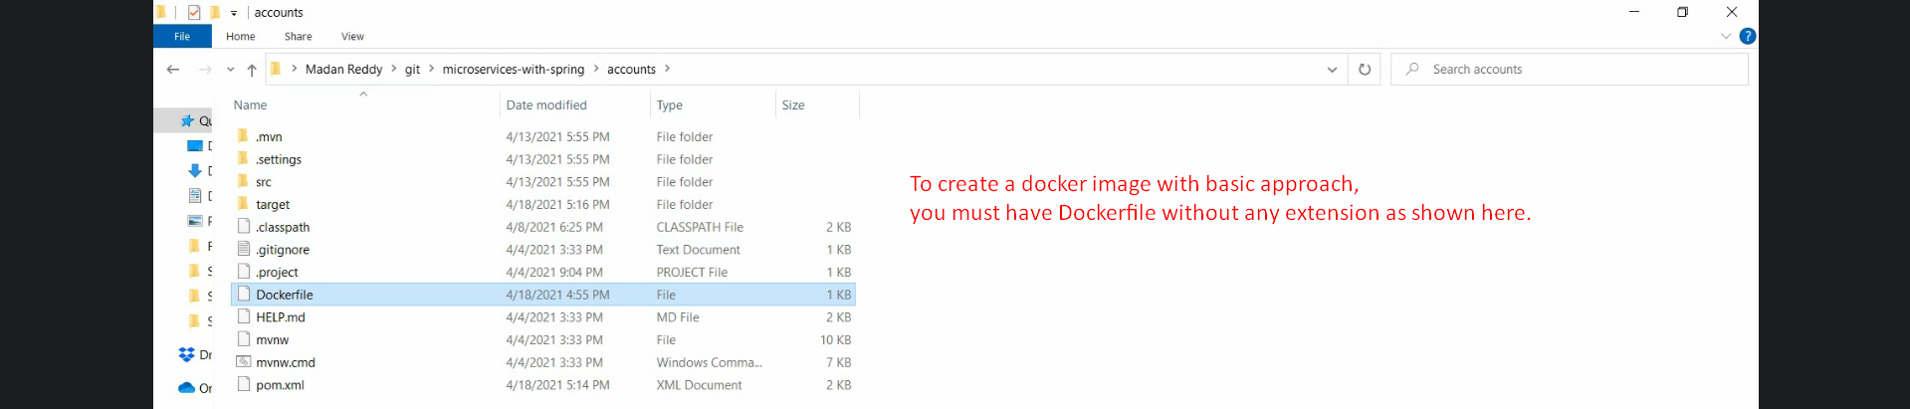
2. A picture containing graphical user interface

   Description automatically generated